**LAPORAN HASIL JAWABAN**

**QUIZ 2 ( PROJECT MANAGEMENT )**



**DISUSUN OLEH:**

**MUHAMMAD ALIF ANANDA (1941720078)**

**PROGRAM STUDI MANAJEMEN INFORMATIKA**

**JURUSAN TEKNOLOGI INFORMASI**

**POLITEKNIK NEGERI MALANG**

**2020**

1. According to your experience during working on your project (your project in Project 1 course), how does your team manage the resources, working schedule, communication, and conflict within your project?

**Answer :**

First of all, were up to the resource when we done with our project idea. We take a several sample and collecting some resources from the average salary around the city for the employee ( graduated student ) and the lecture ( the part of the course lesson also ). Then after we taking some samples from salary we moving to the hosting. In the hosting part. Were taking a reference from the web. And then we decided to choose the cheapest one first for our first project and we counted it without discout same as the domain price. And come the last is the ads. Were taking ads to online marketplace so it gonna be much easier to promote out project. And this is the final result :

|  |  |  |
| --- | --- | --- |
| No. | Jenis Pengeluaran | Biaya (Rp) |
| 1. | Membeli domain | 300,000 / Thn |
| 2. | Membeli Hosting | 680,000 / Bln |
| 3. | Membayar Pemateri | 1,200,000 / Bln ? |
| 4. | Mempromosikan Website | 265,000 / 7 Hari |
|  | **Jumlah** | **2,445,000** |

About the domain, we took the actual prices, and if we divided into a month, then it could be possibly around 22,000+ Rupiah. And for the month prices, it will take for around 2,140,000 rupiah.

About the communication, we held a meeting twice for a week to see how far our progress is, and our project work properly even there was a few mistakes we can solve it together.

The next one were discussing about the schedule. We creating some schedule and we make it fit with

our activity. We creating it from WBS. 

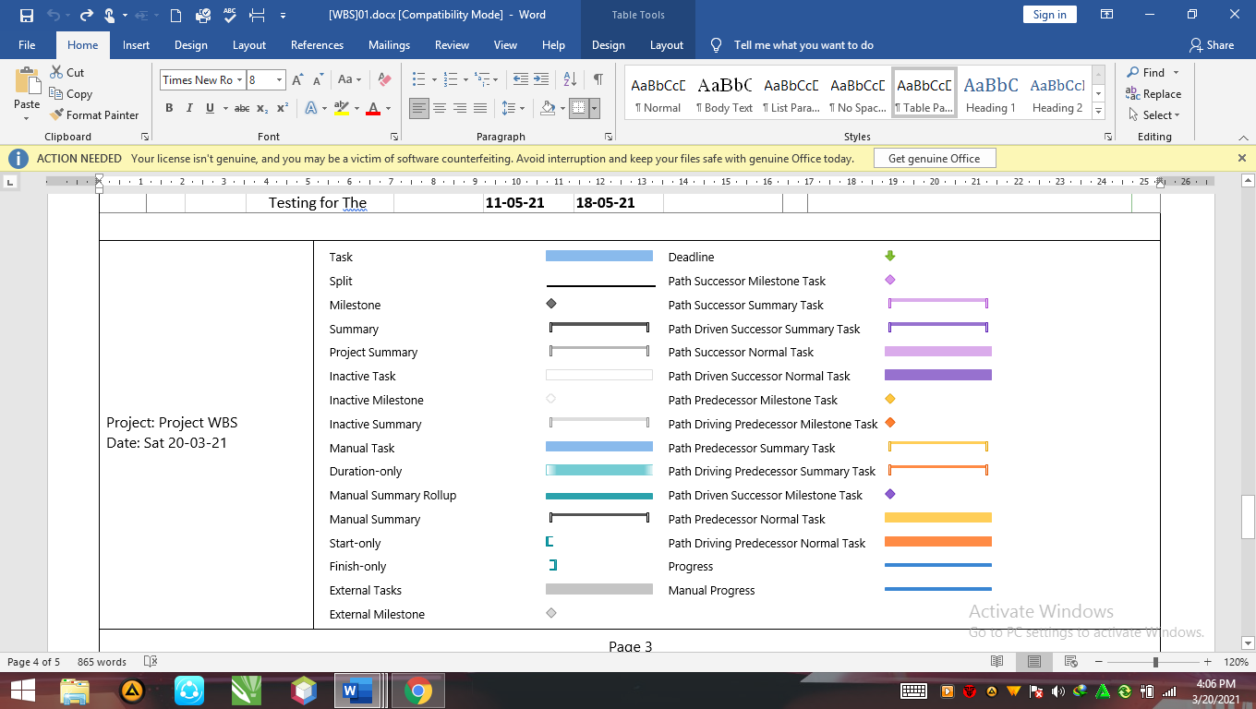

This is one of the result from our schedule. And we decided to finish our project at 21th may 2021.

About the conflict, were planning to do our project when our project is successfully accepted. Then we gonna do the business also.

2. If you are able to improve the managerial process on your project, what will you do? (based on resources, schedule/timing, communication, and conflict management)

**Answer :** If I were able to improve our project, I would gathering our business project with help from outsiders and we gonna make a several discussion for making our project more perfect. We gonna learned so much material from the experienced. We also depending about the campus financial so were gonna serve our project with its finest service like good domain, hosting and more importantly, is our website. We expanding our meeting also from twice to 3-4 times meeting at week so we can finish our project quickly and we can do the rest for focusing our study. For recruiting the fresh graduate, we will take from east java first. So they can come to our place easier.